Методический паспорт к заданию

Авторы-составители:
Гущина Анна Александровна, Сидорова Ю.С.,
учителя иностранного языка

Название задания | А.К.Дойл «Шерлок Холмс»
Место задания в образовательном процессе | Предмет: английский язык  Класс: 9 класс  Тема урока, на котором можно предложить данное задание: Искусство и литература.  Место на уроке (актуализации знаний)
Вид (виды) функциональной грамотности, на формирование которого (которых) направлено задание | - Читательская грамотность  - Естественнонаучная грамотность
Характеристика задания | Характеристика задания, направленного на формирование читательской грамотности, содержит:  ✓ Контекст (образовательный)  ✓ Тип текста (сплошной, несплошной)  ✓ Формируемые читательские компетенции:  Задание 1  Находить и извлекать информацию  Находить и извлекать одну или несколько единиц информации  Интегрировать и интерпретировать информацию;  Соотносить визуальное изображение с вербальным  Задание 2  Интегрировать и интерпретировать информацию;  Понимать значение неизвестного слова или выражения на основе контекста  Соотносить визуальное изображение с вербальным текстом  Задание 3.  Находить и извлекать информацию  Определять место, где содержится искомая информация (фрагмент текста, гиперссылка, ссылка на сайт и т.д.)  Задание 4.  Осмысливать и оценивать содержание и форму текста;  Оценивать полноту, достоверность информации 3.5. Обнаруживать противоречия, содержащиеся в одном или нескольких текстах  Задание 5.  ЧГ. Использовать информацию из текста  Формулировать на основе полученной из текста информации собственную гипотезу  ЕНГ. Интерпретация данных и использование научных доказательств для получения выводов  Анализировать, интерпретировать данные и делать соответствующие выводы  ✓ Формат ответа: краткий ответ, развернутый ответ
Решение к заданию | Задание 1  - T  - T  - F  - F  - F  - T  - F  - T  Задание 2.  1. Гончая  2. Ищейка  3. Мастиф  Задание 3.  1. The giant hound was dead.  2. giant, as large as a small lioness, the huge jaws  3. the dreadful, shimmering head, the huge jaws seemed to be dripping with a bluish flame, cruel eyes were ringed with fire.  4. Phosphorus  Задание 4.  Appearance of The Hound of the Baskervilles  Real Unreal  giant, as large as a small lioness, it was not a pure bloodhound and it was not a pure mastiff the dreadful, shimmering head, the huge jaws seemed to be dripping with a bluish flame, cruel eyes were ringed with fire.  Задание 5.  Using the text express their own point of view.  Используя текст, выражают свою точку зрения.

Fact file

Задание 1.
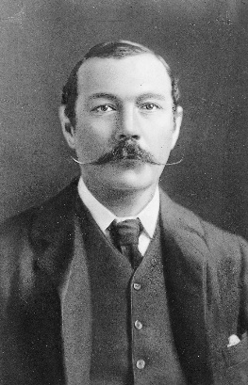
Learn the fact file about Sir Arthur Conan Doyle and mark the statements
Sir Arthur Conan Doyle
T (TRUE) or F (FALSE):
Изучите fact file об Артуре Конане Дойле и отметьте утверждения T (Правда) или F (Ложь):

- Sir Arthur Conan Doyle had two sons and a daughter. ____
- The writer was born in Scotland. _________
- Arthur Conan Doyle was an English poet. _____
- Arthur Conan Doyle wrote only detectives. ________
- Conan Doyle was the writer of the XVIII century. ________
- Doyle studied medicine at the University of Edinburgh Medical School. _______
- The most famous Doyle’s character is Hercule Poirot. ______
- Doyle’s books were filmed in different countries. ______

Sherlock Holmes
Arthur Conan Doyle was the one who created the world-famous character Sherlock Holmes. This brilliant English detective can now be seen in many films, cartoons and even computer games. No doubt that it’s a fictional character, but everyone takes him for granted.
He was created in 1885 after the author wrote a series of short detective stories about him. He first appeared in a book called “Study in Scarlet”. Later Doyle wrote “The Adventures of Sherlock Holmes” and this book made him famous all over the world. People know that this hero lived in London on Baker Street. The house where he lived according to the books is now a museum. While visiting it, people can feel the atmosphere of the 19th century England.
Holmes was a highly intelligent man with an extremely rich imagination, observation and analytical skills. His human qualities are as well as his intellectual abilities. He was brave, honest, fair and multi-talented. He was well familiar with many other related sciences besides his profession, for example, anatomy, geology, chemistry, pharmacology etc. In his free time he enjoyed playing the violin and smoking a pipe.
One of his qualities most was that he never refused to help people who were in trouble. He didn’t ask for large fee for his help. Sometimes he even did it for free.
However, he wasn’t the only character in Doyle’s detective stories. Holmes had a sincere friend and dedicated assistant, whose name was Dr. John Watson.
Complete the sentences with right words:

Задание 2.
Look at the pictures of dogs and guess what the translation of these dogs breeds.
Посмотрите на картинки собак и догадайтесь, какой перевод данным породам.

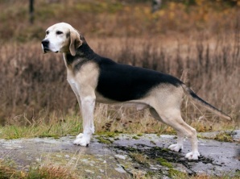  1. | Hound
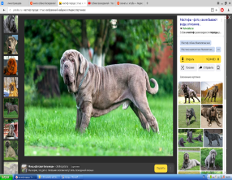  2. | Bloodhound
3. | Mastiff

Задание 3.
Read the text and aswer the questions.
Прочитайте текст и ответьте на вопросы.

The Hound of the Baskervilles
... I (Sherlock) stooped, panting, and pressed my pistol to the dreadful, shimmering head, but it was useless to press the trigger. The giant hound was dead.
… In mere size and strength it was a terrible creature which was lying stretched before us. It was not a pure bloodhound and it was not a pure mastiff; but it appeared to be a combination of the two—gaunt, savage, and as large as a small lioness. Even now in the stillness of death, the huge jaws seemed to be dripping with a bluish flame and the small, deep-set, cruel eyes were ringed with fire. I placed my hand upon the glowing muzzle, and as I held them up my own fingers smouldered and gleamed in the darkness.
"Phosphorus," I said.

1. Why didn`t Sherlock Holmes press the trigger?
2. What kind of size was the hound?
3. What unusual did Sherlock find in dog`s appearance?
4. What did Sherlock notice on his fingers?

Задание 4.
Read the text and complete the table
Заполните таблицу.

Appearance of The Hound of the Baskervilles
Real | Unreal

Задание 5.
Read the text and choose the right hypothese. Explain your answer.
Прочитайте текст и выберите правильную гипотезу. Объясните свой ответ.

1. There is a mastiff in the book.
2. There is a hound in the book.
3. There is a bloodhound in the book.
4. There is a hybrid in the book

